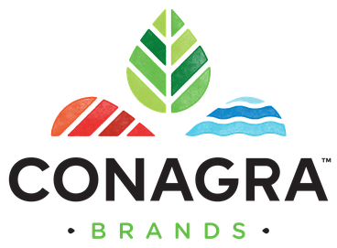

**Report 2**

**Project Title:** Create data-driven strategies to help Conagra unlock future growth potential in the Meat Substitutes category

**Report Date:** 03/31/2024

**Group 11 Members:**

Albin Poulose – AXP220239

Ashiq Mohammed Al Ameen - AXA220171

Azime Gulin Divarci - AGD220003

Bhavana Balagopal – BXB220057

Priyanka Das - [PXD230010](mailto:pxd230010@utdallas.edu)

Srivani Kakumani - SXK230164

Suman Anand – SXA230187

**Introduction:**

In the rapidly evolving food sector, the emergence of meat substitutes has marked a significant shift in consumption patterns. These alternatives address the growing consumer inclination towards products that are not only health-oriented but also align with the ideals of sustainability and ethical consumption. As such, the demand for meat substitutes, which offer similar taste, texture, and nutritional profiles as traditional meat without associated health or ethical compromises, is on an ascent.

The integration of meat substitutes into the market is a response to not only a diverse consumer base’s preference but also represents a strategic move towards a sustainable and equitable food system designed for the long-term benefit of society. Conventional meat production, despite fulfilling global dietary needs, poses severe environmental challenges. It contributes to greenhouse gas emissions, consumes vast quantities of water, and accelerates deforestation, undermining ecological stability.

Conagra's strategic expansion into the meat substitute arena is a proactive step in line with its environmental ethos and corporate accountability. It signifies a commitment to fostering an environmentally responsible food industry. This report outlines the initiative to explore the market for meat substitutes with the vision to drive substantial change, spur innovation, and mobilize collaborative efforts for a future that is environmentally sustainable and resilient for all stakeholders involved.

**Data Description:**

In the Conagra dataset, there are several distinct types of datasets:

FZ Meat_POS, FZ Seafood_POS, FZ_RFG Poultry_POS, FZ_RFG Processed, Poultry_POS, FZ_RFG Substitute Meat_POS, RFG Bkfst Meats_POS, RFG, Dinner SSG_POS, RFG Frankfurters_POS, RFG Ham_POS, RFG Lunch, Meats_POS, RFG Meat_POS, RFG Seafood_POS.

**FZ Meat_POS:** This dataset likely contains information about frozen meat products, and "_POS" suggests it includes point-of-sale data, such as sales quantity, revenue, and possibly customer demographics.

**FZ Seafood_POS:** Like FZ Meat_POS, this dataset likely focuses on frozen seafood products and their sales at the point of sale.

**FZ_RFG Poultry_POS:** This dataset probably includes data on ready-to-eat (RFG) frozen poultry products, with POS showing it has point-of-sale information.

**FZ_RFG Processed Poultry_POS:** Like the earlier dataset, this one likely focuses on ready-to-eat processed poultry products that are frozen, with point-of-sale data included.

**FZ_RFG Substitute Meat_POS:** This dataset may have information about frozen ready-to-eat substitute meat products, possibly including plant-based meat alternatives, with point-of-sale data included.

**RFG Bkfst Meats_POS:** This dataset may have information about ready-to-eat breakfast meat products, such as bacon or sausage, with point-of-sale data included.

**RFG Dinner SSG_POS:** This dataset likely focuses on ready-to-eat dinner sausage products, with POS showing it has point-of-sale information.

**RFG Frankfurters_POS:** This dataset probably includes data specifically related to ready-to-eat frankfurter products, with point-of-sale data included.

**RFG Ham_POS:** This dataset may have information about ready-to-eat ham products, with point-of-sale data included. GROUP-11

**RFG Lunch Meats_POS:** This dataset likely contains data on ready-to-eat lunch meat products, such as deli meats, with point-of-sale information included.

**RFG Meat_POS:** This dataset may focus on other types of ready-to-eat meat products not covered by the earlier categories, with point-of-sale data included.

**RFG Seafood_POS:** Like the earlier dataset, this one likely focuses on ready-to-eat seafood products, such as canned tuna or shrimp, with point-of-sale data included.

**For each dataset available from 2020 to 2024, there are various variables and attributes. Here's a rewritten description of the data:**

**Explanation of Variables:**

**Geography**: This refers to the geographical location where the sales data was collected, typically categorized by regions, states, cities, or specific store locations.

**Product:** This variable finds the specific product being sold, often categorized by product type, brand, flavor, or variant.

**Time:** This variable shows the time in which the sales data was recorded, typically segmented by date, week, month, quarter, or year.

**UPC (Universal Product Code) 13 digit**: The UPC is a unique 13-digit code assigned to each product for identification purposes. It's commonly used in retail and allows for right tracking of product sales.

**ACV (All Commodity Volume) Weighted Distribution:** ACV Weighted Distribution measures the availability of the product across different retail outlets, weighted by the size of each outlet. It shows the product's distribution reach in the market.

**Base Dollar Sales**: This stands for the total dollar amount of sales generated by a product during a specified period, excluding any promotional or incremental sales.

**Base Unit Sales:** Like Base Dollar Sales, this variable is the total number of units sold for a product during a specified period, excluding any promotional or incremental sales. GROUP-11

**Base Volume Sales**: This refers to the total volume of product sold (e.g., in Liters or gallons) during a specified period, excluding any promotional or incremental sales.

**Dollar Sales**: Total dollar amount of sales generated by a product during a specified time, including both base sales and any incremental sales resulting from promotions or other factors.

**Incremental Dollars:** The added dollar sales generated by a product due to promotional activities or other factors beyond the base sales.

**Incremental Units:** The added units sold for a product due to promotional activities or other factors beyond the base sales.

**Incremental Volume:** The added volume of product sold (e.g., in Liters or gallons) due to promotional activities or other factors beyond the base sales.

**Price per Unit**: The average price of the product per individual unit sold, calculated by dividing the total dollar sales by the total unit sales.

**Price per Volume:** The average price of the product per volume unit sold (e.g., per liter or gallon), calculated by dividing the total dollar sales by the total volume sales.

**Unit Sales:** Total number of units sold for a product during a specified time, including both base sales and any incremental sales.

**Volume Sales:** Total volume of product sold (e.g., in Liters or gallons) during a specified time, including both base sales and any incremental sales.

**Test (Count):** This variable likely represents the count of a particular test or experiment conducted within the dataset, providing information about the frequency or occurrence of a specific event or condition.

**Problem Statement:**

Conagra’s FZ Meat Substitutes category is facing a pressing issue with a noticeable decline of 1.2% in the total number of buyers since 2020. This decline raises concerns about the category's market penetration and consumer appeal. Understanding the underlying reasons behind this decrease is essential for stakeholders in the food industry, particularly for Conagra (FZ Meat Substitutes,) to address the challenges and implement effective strategies to reverse this trend. The problem at hand is to investigate the factors contributing to the reduction in buyers and formulate actionable solutions to reinvigorate interest and engagement within the FZ Meat Substitutes category.

**Objective and Scope**:

This project is crafted to offer Conagra Brands a strategic perspective on the meat substitutes industry. It encompasses an extensive analysis of the market size, growth trajectory, consumer trends, competitive analysis, and regulatory considerations. The insights presented herein aim to underpin Conagra's strategic decisions concerning market penetration and growth, ensuring alignment with consumer expectations and environmental imperatives.

**Analysis Approach**:

**The key steps involved in this analysis include:**

**Exploratory Data Analysis:**

1. **Descriptive Analysis and Summary of Data:** Describing,Examining, and summarizing data to extract insights.
2. **Univariate Analysis:** Summary of statistics of significant variables on Central Tendency, Dispersion, Skewness along with visualizations through various Histograms and Box plots etc.
3. **Multivariate Analysis**: Analyze Covariance, Correlation and Correlation Matrix with some visualizations e.g. Scatter Plots with color and Heat Maps etc.
4. **Data Cleansing:** Addressing missing values and outliers, ensuring data consistency and quality.

**Predictive Modelling**: This step involves constructing regression models, including but not limited to Linear Regression, Polynomial Regression, and Logistic Regression. The effectiveness of these models will be evaluated through metrics such as the confusion matrix, accuracy, sensitivity, and ROC curve. Optimization of the models will be performed using methodologies like Gradient Descent. We will examine statistical significance of our findings by performing various statistical tests like t-test, f-test and ANOVA etc.

**Key Questions we are working on our Project:**

* Does the size of the packaging impact sales?
* Does the discount impact the high performing products and low performing product?

Top 5 products with highest unit sales

Comparison of Top 5 products of Dollar sales no merch vs Dollar sales any merch

Comparison of Top 5 products of Unit sales no Merch vs Unit sales any merch

While analyzing this part we found that the percentage of sales by discount is higher than the normal sales. We calculated this in Python by taking into consideration of the following below fields:

Product

Dollar Sales

Unit Sales

Dollar Sales Price Reductions Only

Unit Sales Price Reductions Only

Below is the Python code and it’s result for reference:

* Does location have an impact on sales of different products?

Comparison of Meat Substitute Sales across various regions in US

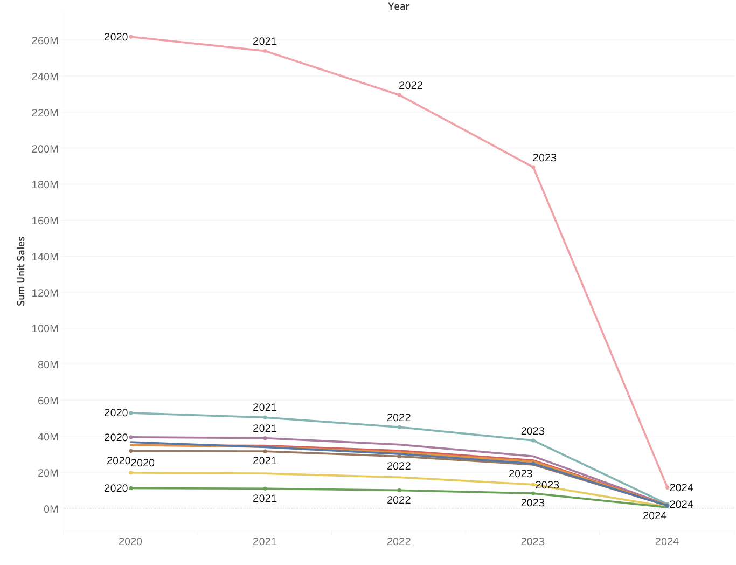

As per our analysis so far, we have found that the percentage of Sales for Northeast, Southeast and Mid-South were highest being 10.42%, 7.44% and 6.99% respectively. The bottom ones are South Central and Plains at 3.31% and 2.19% respectively.

Below are the Python Code and tableau Visualization:

**Conclusion:**

Our analysis forecasts that the variables of packaging size, discount offerings, and regional distribution channels will continue to be significant determinants of meat substitute sales success or not? It is anticipated that larger packaging will maintain higher sales volumes, and the effectiveness of discounts will likely differ between products with varying levels of demand. We also expect regional preferences to persist, steering consumer purchasing behaviors. Conagra Brands' strategic commitment to sustainability is projected to resonate well with evolving consumer preferences, enhancing its potential to secure and expand its market leadership.

Top of Form

Bottom of Form